October 2022 –Scribblers Christian Writers Group
Lilburn Chapter
- Tuesday, October 18, 2022 at 6:00 PM
- Meeting at Five Forks Library -2780 Five Forks Trickum Road, Lawrenceville, Georgia, 30044-5865 770-978-5600 (Mike Owens is chapter leader – 225-315-0851)

Agenda
- Meet and Greet – Introduction of each attending member - Please do register on the WebSite (www.scribblersweb.com) that you are attending.

- Business Items:
- www.scribblersweb.com site
Scribblers Christian Writers Book Store Report:

The Scribblers’ Book Store Had No Book Sales In September 2022
2) On Amazon in the month of August we had 6 Book Sales (6Paperbacks)
Anthony Miller sold 1 of Dearest Doris
Marlene Buchanan sold 1 A Place With A Past
Mike Owens sold 2 of I Hate Vegetables Book Of Poetry For Kids, and 1 Camelino: The Little Camel Who Met Little Jesus
Geri Mehta sold 1 of Princess Party Manners
All royalty checks were mailed on Monday October 3, 2022. . Please be sure to deposit the checks when you receive them. You receive 90% of the sale price minus credit card fees for sales coming from the Scribblers Book Store and 90% of the royalty received from Amazon KDP sales. Please note that the minimum deduction from the royalty is the greater of 10% or the royalty or the cost of the 1st class stamp to mail your royalty. (Currently $.53) I am sending out the detailed report to each author who had sales in the month.
Currently : 31 authors with 85 Books are currently in the book store.

- Marketing Report
Marketing is with out doubt the single largest need and expense authors have. The following are some of the marketing opportunities that Scribblers Christian Writers Group have been or will be involved in.
September 2022 Reports

Doc Holiday Festival - Arts & Crafts Vendor – Saturday, September 10
Deadline: Sep 02, 2022 11:59 pm (GMT-04:00) Eastern Time (US & Canada)

Mike Owens Report On Doc Holiday Festival -Saturday September 10

Leda and I attended the Doc Holiday Festival in Griffin, Georgia for the first time on Saturday, September 10th . I believe the weather played a role in the low festival turn out - it rained during set up and poured for take-down. We sold seven books which barely paid for our booth and our food, so we basically broke even. We had to hustle to get that many sales. I worked the front of the booth and Leda worked the back. It was necessary to engage customers as they were walking past the booth to get any response at all. When we did get them to enter our booth we occasionally would make a sale. The layout of the park for all the vendors seemed haphazard and disconnected, plus the signage directing you to the registration area and the location of your booth was nonexistent and it took us a lot of time to find where we were to set up. The food was a disappointment and pricey. (The cookie vendor across from us made a killing. Leda and I are thinking about adding “book-shaped cookies” to our product line next year!). If Julie and Donna do not return, we may not either.

Donna Barron Report On Doc Holiday Festival – Saturday September 10, 2022

he threatening rain held off, but the crowd level was way down from last year. I was able to sell only 1 book late in the day. One lady of interest told me she was a genealogist and I need to donate my book in the Georgia Archives, Atlanta History Center, and other local libraries, especially those with genealogical records. The festival was too spread out, and when I would walk around in my period outfit – I would get good comments, but no one I spoke with came to the booth. We were near the entertainment section, and there were very few non-food vendors in our area. There were no lines at all for the food vendors, which indicates either a very low turnout, or people were not buying that day. It turned out not to be a good location in my opinion, and I will probably not return next year.

ART IN THE PARK 2022, September 17 & 18th Hurricane Shoals Park –
This is the second year Scribblers has been present at the Art In The Park, although Scribbler Members have done this event in the past, but as standalone authors not under the banner of being Scribblers Christian Writers Group.
Frankly this year everything lined up wonderfully and in retrospect we probably had the single best show event , (other than the Decatur Book Festival in 2019) that Scribblers has ever had. The weather, always a major factor in turnout was incredible. Low 80’s low humidity and bright sun for both days produced a wonderful turn out, even if there were fewer vendors this year than last,
We had five authors and a total of eight people present for the show, Mike and Leda Owens, Donna and Ron Barron, Julie and Rick Clarke, Tyler Root, and Charles de Andrade. Mike and Leda sold an incredible 37 books and also some of Leda’s art work. Donna and Ron reported 12 books with 1/2 dozen opportunities to speak at the Jefferson American Legion, Historical Society, Lyons Club, Jefferson Library, etc. I was in the booth next to Tyler Root and while I do not have the exact count I know our youngest author had at least 10 and likely more sales for the one day he was able to be there. (He was a natural sales person dropping his, “ you want to see the book I wrote and illustrated when I was five years old?” Rick and Julie Clarke also sold 4 books and Julie played music on the mountain dulcimer that came from her new books as well. . I had a total of six books. However, even my low sales came with a silver lining, as one person that had bought one of my books last year, returned this year to purchase another. It is amazing how much that event lifted my spirits, as it meant someone saw enough value to come back and pick up the next book in the series.

Obviously the “downer” for the show was the fact that I fell as we were packing up and that fall has impacted my ability to be mobile for the next few months. But despite that negative event I believe we will all be back next year, as this was a very product show all around.

Upcoming Marketing Events

Scribblers will have a table at this Local Art and Craft Show In Florida.
Charles will be bringing a selection of books from the book store to the show, as well as his own books.
This is the second pf three shows in Florida that Scribblers will be represented at.
If you would like your books to be on display and sold at the show the cost is 15% of any sale that is made to help cover the costs for the show. Let Charles know if you would like your book be included. You only pay, if a sale is made!
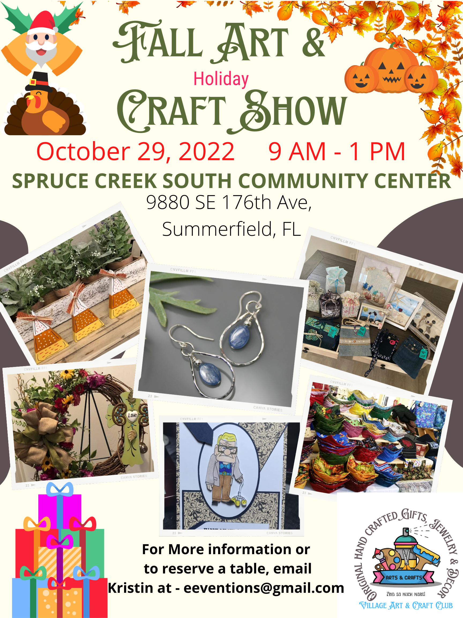

- Resource Presentation : (Pending)

- Questions on publishing or any other questions from visitors

- Upcoming New Book Releases

  - Richard Willionis – Stories For Ava
  - Ashley Price - Clukie’s Chicken Pox
  - Charles de Andrade – Chosen – Audible
  - Lynn Hesse – A Matter Of Respect
Others?

Scribblers Meetings in October – December 2022

Notice: Due to the injury I sustained at the Art In The Park Festival I will not be able to be leading the chapter meetings until January 2023. Because of that change in my mobility we are going to be holding ZOOM Only meetings for the Summerfield, FL, Orlando FL, Macon GA, Norcross GA and Snellville GA Chapters for the October and November 2022 meetings.. The only chapter that will continue to have in person meetings during these months is the Lilburn Chapter led by Mike Owens.
In December the only meeting we will be having is the ZOOM meeting on Monday December 26. 2022 at 6:00 PM.

- Lilburn, GA Chapter –
- Tuesday, October 18, 2022 at 6:00 PM
- Tuesday, November 15, 2022 at 6:00 PM
- Meeting at Five Forks Library -2780 Five Forks Trickum Road, Lawrenceville, Georgia, 30044-5865 770-978-5600 (Mike Owens is chapter leader – 225-315-0851)

- Virtual/ZOOM Chapter – All Chapters Except Lilburn
- Monday, October 31, 2022 at 6:00 PM ( Yes, that is right, the last Monday in October is Halloween! Prepare for a spooky meeting!)
- Monday, November 28, 2022 at 6:00 PM
- Monday, December 26, 2021 at 6:00 PM
- (Charles de Andrade is chapter leader – 772-584-1578) The invite for the meeting is here: https://us02web.zoom.us/j/86306717298

Please remember to register for which meeting(s) you are coming to by going to the Scribblers Christian Writers Website at www.scribblersweb.com. Select Meetings - Scribblers Christian Writers Group (Meetings - Scribblers Christian Writers Group) and on the pull-down select the chapter you wish to attend. You must register so that the Chapter Leader knows how to set up for the meeting and whether to wait if you are coming. Also, remember you are welcome to attend as many meetings (both in-person and virtual) as you like.

Finally, you can check the agenda for each chapter’s meeting by going to the Scribblers Christian Writers Website at www.scribblersweb.com. Select Events - Scribblers Christian Writers Group (Events - Scribblers Christian Writers Group) and then scroll to the AGENDA tab. When you click the tab it will export the agenda to a word document for you to print out.

- Resource Review :
  - Have you used any of the resources to this point and what is your experience?

- Christmas Gathering:
It’s Feeling A Lot, Like Christmas!”

“The Village Corner” the German restaurant located at 6655 James B Rivers Drive, Stone Mountain, GA 30083 that we will be holding our event there again this year.
Tuesday December 20, 2022
Head Count For The Dinner - ??

As normal, you are welcome to bring your family and friends. Just remember that everyone is buying their own dinners. And as normal our not so secret, secret Santa and Mrs. Claus are scheduled to be there as well. Hard to believe it, but this will be our 7th Christmas together as Scribblers Christian Writers Group.

- The Critics Corner aka “The Inklings Moment”- Scribblers Corner : Every month one or two of our authors will review something they are working on. The intent of this period is to give the author the opportunity to have other authors read, hear, and comment on what the author is writing. This is meant as a period of encouragement, and of constructive review. What did you like about what the author wrote? What did you learn from what was written? What could be improved upon? This also give the author the opportunity to discuss what is behind what is written. If you would like to be included in next month’s review, please contact your chapter leader and provide up to 4 pages of content.

This Month’s Review – Pending

.

